Messaging

The “Messaging” label is located on the right side of the Toolbar. Clicking on it opens NetView Messenger, an instant messaging application which lets you send and receive messages to other NetView Desktop users.  The application also lets you send group messages to designated batches of users.

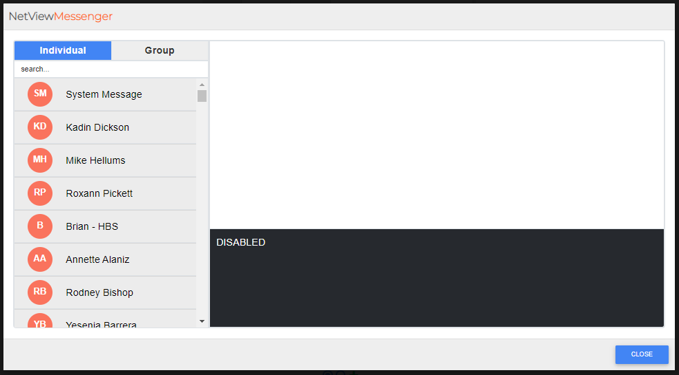

**Individual Messaging:** To communicate with an individual through the system, make sure you have “Individual” selected at the top of the window (this is the **default** selection). The users will be listed with the user you most recently sent or received a message from at the top. Choose the other user’s name from the left-hand panel, or find it by typing the user’s name in the **Search** field.

Selecting the user will activate the message panel on the right (it will read **DISABLED** until active **OR** unless you selected the **System Message** option). Enter the desired message in the field and hit the “Enter” key. The top portion of the panel will then show the sent message. The panel will also display all prior communication between you and the other user.

System Message: The System Message “user” represents the system itself sending you messages and notification, which you cannot respond to.

Message Indicators: You can see how many “unread” messages you have from another user via an indicator which will show the number of messages next to that user’s name. Additionally, if you receive a new message from a user while looking at an older message higher up in the user’s messaging panel, a notification will display at the top of the message window. Clicking the notification will automatically scroll the panel to the bottom so you can read the new message.

**Group Messaging:** To communicate with all users of any group you may be included in, click on the “Group” option at the top of the window. The left-hand panel will replace the list of individual users with the list of your groups (as recorded in the system by the administrator):

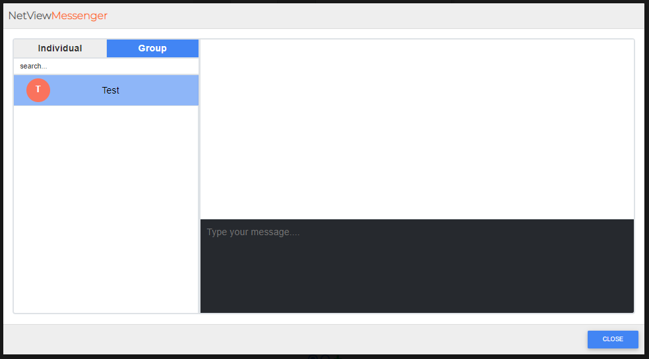

Select the group you want to message and enter the message as you would to an individual. All messaging between members of your group will display in the right-hand messaging panel. **NOTE:** The messaging panel for Groups functions exactly the same way as the Individual messaging panel, including the message indicators (see above).

**Close:** Click this button to close the application and return to the main Desktop.